华南理工大学
《课程名称》课程实验报告
实验题目：The QuickSort Algorithm
姓名： 谭演锋 学号： 202130100456
班级： 计算机全英联合班 组别： 无
合作者： 无
指导教师： 颜小洋
实验概述
【实验目的及要求】
实验目的：
Apply several sorting algorithms to solve sorting problems and compare the efficiency of different sorting algorithms in various problem sizes and draw the corresponding efficiency diagrams of these algorithms. (Specific requirements: specify the number of data n, then randomly generate a type of initialization data, use several different sorting algorithms to sort it, output the corresponding results and the time used, change n and then use the same types of sorting the algorithm completes the sorting, draws the n-t diagram of the corresponding algorithm according to the result, and compares the difference in efficiency.)
实验要求：
The template should be used for all kinds of data type, such as: integer, real, double, etc. in the program.
Programs should be made by Object-Oriented Programming (OOP) method.
The results should be compared with ones of other algorithms, such as: Straight selection sort, insert sort, etc., and draw the graph to find their differences.
Write down the report in which there should be the execution results of the program.
【实验环境】
操作系统：Windows XP
实验内容
【实验过程】
- 实验步骤：
(1)Definition of class and function：
Class: C_Alg

Data member:
N: In the form of adjacency matrix
fD: store the data that required to sort
Member functions:
swap: swap two value of the fD array
partition: according to the pivot partition the fD array into two part one is larger than then the pivot one is smaller than the pivot.
Merge：Merge two sorted arrays into a sorted array
Quicksort: Run the quick sort to sort the data
stright_selectionSort: Run the straight selection sort to sort the data
insertSort：Run the insertion sort to sort the data
bubbleSort: Run the bubble sort to sort the data
MergeSort: Run the merge sort to sort the data
get_fD: return the fD
Set_fD: set the fD
(2)Run program in the main function:
For n = 200 to 2000 each time n+=200
Initial the fD use the rand () function to create the integer which range is[0,n] n is the size of the array.
Call 5 sort algorithms to sort the fD array. Then calculate their running time.
二、实验数据：
We use the rand() function to create different number of integers (from 200 to 2000 each time plus 200) with different value.

三、实验主要过程
Quick Sort：
Input: a_{f ,} a_{f+1} , … , a_{l}
output: The sorted sequence of a_{f ,} a_{f+1} , … , a_{l}
If f ≥1,then Return
X:= a_{f}
i := f + 1
j :=I
While i <j do
Begin
While a_{j} ≥ X and j ≥f+1 do
j:= j- 1
While a_{j} ≤X and I ≤ l do
i := i + 1
if i<j then swap (a_{i ,} a_{j})
End
swap (a_{f} , a_{j})
Quicksort (f, j - 1)
Quicksort (j+1, l)
Straight Selection Sort:
input: x₁, x₂, ..., x_{n}
output: The sorted sequence of x1, x2, …, x_{n}
For j:= 1 to n- 1 do
Begin
f: = j
For k := j + 1 to n do
If x_{k} < x_{f} then
f: = k
swap(x_{k,} x_{f})
End

Insertion Sort:
input: x₁, x₂, ..., x_{n}
output: The sorted sequence of x1, x2,… , x_{n}
For j:= 2 to n do
Begin
i := j- 1
x := x1
While x < xi and i > 0 do
Begin
x_{i+I} := x_{i}
i: = i- 1
End
x_{i+1} :=x
End

Merge Sort:
input: x_{l}, x_{l+1}, ..., x_{h}
output: The sorted sequence of x_{l}, x_{l+1}, ..., x_{h}
if l<h then
mid := (l+h)/2
MergeSort(l,mid)
MergeSort(mid+1,h)
i:=low
j:=mid+1
k:=0
Temp[h-l+1]
While i<=mid&&j<=high do
Begin
If x_{i}<x_{j} then temp[k++]=arr[i++]
Else do temp[k++]=arr[j++];
End
While i<=mid do
Begin
temp[k++]=arr[i++]
End
While j<=high do
Begin
temp[k++]=arr[j++];
End
k:=0
For i:=low to h do
Begin
k++
arr[i]=temp[k];
End
Bubble Sort:
input: x₁, x₂, ..., x_{n}
output: The sorted sequence of x1, x2,… , x_{n}
For k:= 1 to n do
Begin
For j:= 1 to n-k do
Begin
If x_{j} > x_{j+1} then swap(x_{j} , x_{j+1})
end
End
三、实验结果：
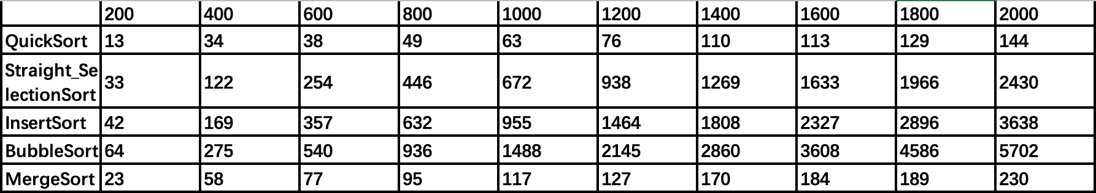
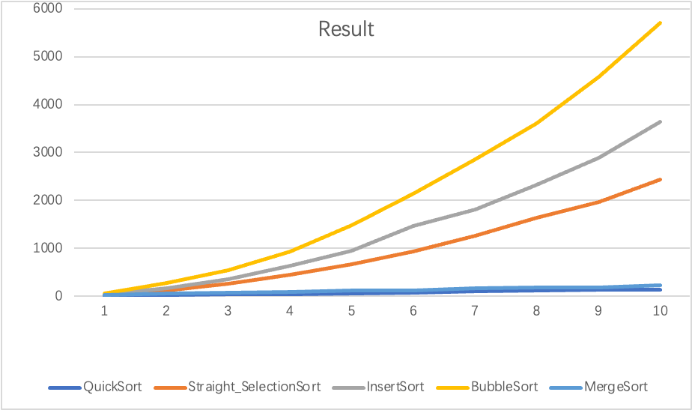

小结
After the experiment, I was more familiar with how the code the sorting algorithms and the main thought of different sorting algorithm. Additionally, I also knew that the speed of different sorting algorithms and the tremendously different between O(n^2) and the O(nlogn) when n become larger. Finally, I know why quicksort is called quicksort since it is the fastest algorithm. Although, quicksort and mergesort both have the time complexity of O(nlogn) but their speed are different since they have different coefficients. I also know that the bubblesort is the slowest algorithm.
指导教师评语及成绩
评语：

成绩： 指导教师签名：
批阅日期：

